Essay Writing and Helping Service
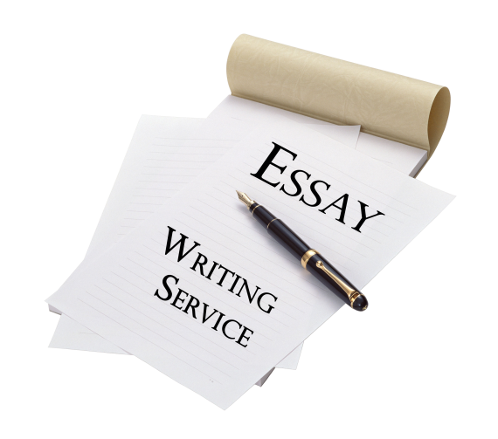
Nowadays essays become more popular and use in the various spheres of our life: starting with education till jobs and mass-media. Usually it helps people to understand the features of your thinking and potential more clearly. In this article you’ll discover the most important aspects of essay writing and good service for help to deal with it.
What is it – essay writing and which service should use?
Essay – is a short composition, which shows person’s opinions or impressions. It’s something between the artistic and journalistic art. If writing essay seems to you so complicated, you may use an excellent essay writing service: https://paidpapers.com/. Be sure, these professionals will help you in this task!
Writing essays remember that it has:
- minor content;
- specific topic;
- unobtrusive composition.
Before writing essay you must divide all parts of creating it. There are several of them. It goes without saying, that it is analyzing and choosing the topic of your text. It should be something when you are good at, you are an expert. Gather material – make some notes, find necessary information in the Internet, books. Essay should be full of facts and details. Formulate the main problem in the form of a question. It will help you during writing. Think which literature tricks you are going to use to make your language more exciting (comparison, epithets, metaphors, etc.) And then put all your ideas on the sheet of paper. Don’t be afraid to write the first sentence. Just try! And the flow of thoughts will help you to get the right distance. Now let’s go deeper and see into the structure of our essay.
Essay writing structure
- Introduction (determination of the main question);
- The main part (the answer on the question);
- Conclusion (sum up everything and the final answer to the essay question).
Also, when you write an exciting text you have some variants how to start it to catch people’s attention. First of all, you may use standard form. It is the most popular one, but it doesn’t mean that it’s boring. No! Just on the beginning answer on the 6 question: who, what, when, where, why and how. It looks like press release, isn’t it? Answers must inform readers what they can expect. Then: surprising variant. This way shocks and person wants to read more and more. Informative, too. The advantage is that reader gets information so quickly about the following events. The best variant to start your essay – use the perfect quote. It should be connected with the essay’s topic. And don’t forget about dialog form. It’s like a dialog with the readers. On the other hand, it can be just flow of your thoughts.
Requirements to writing essay
- Essay must be perceived like an ensemble, the idea should be understandable and clear;
- In the essay you can’t include unimportant information, only all necessary facts to develop your idea;
- It must have competent compositional construction and be logical;
- Every paragraph has only one thought, idea;
- Essay must show that writer comprehend different theoretical notions, terms, ideas;
- And of course, it should contain the convincing arguments (they are arguments and counterarguments).
Let’s talk about the last point – arguments. It has several types:
- Logical (facts, science’s conclusions (theories, hypotheses, etc.), the laws of nature, statistics, official documents);
- Illustrative (the literature example from the composition, the example from the life or the example that could be);

- Authority as an example (an opinion of the famous person – scientist, philosopher, quote from the well-known source, opinion of the eyewitnesses, etc.)
It is very important to write informative, clear to everyone essays, but also it must be creative. This small part makes your essay really colorful and unique. So, here are 8 rules for writing creative essay:
- Conciseness.
- Understandable words. Your write to shock people with your content, not with your vocabulary;
- Different sentence’s structure. It is a bit boring to read sentences only with the right structure. Add some inversion – make your essay dissimilar;
- Use various words – it means synonyms;
- Only positive language. It is much better to describe what you have than what you don’t;
- Use connection words. They help to make smooth transition between paragraphs;
- Every word is important – without repetitions. Every sentence must show unique content;
- The active life position!
When you finish essay writing necessarily check it out. Most of us forget about it, but check everything – spelling, grammar, punctuation. If you find some mistake – edit it. Then you’ll be sure that your text is on the highest level!
As you can see, essay writing has a lot of aspects and doesn’t an easy task for somebody. But only keeping in your mind all this rules, pieces of advice, suggestions you will be able to make really good product, really good essay, which will catch a lot of attention and, of course, will get the best result!

